AI-Based Lead Intent & Priority Scorer Roadmap

🚀 1. First, understand what we're building
Project: AI-Based Lead Intent & Priority Scorer
The objective: Predict which prospective students are most likely to take admission and help admission counsellors prioritize their follow-up calls.
Imagine a university receives 1,000 admission enquiries.
The counsellor has limited time. Which student should they contact first?
Our application will help answer that question.
Example of the final application
Imagine the dashboard displays the following:
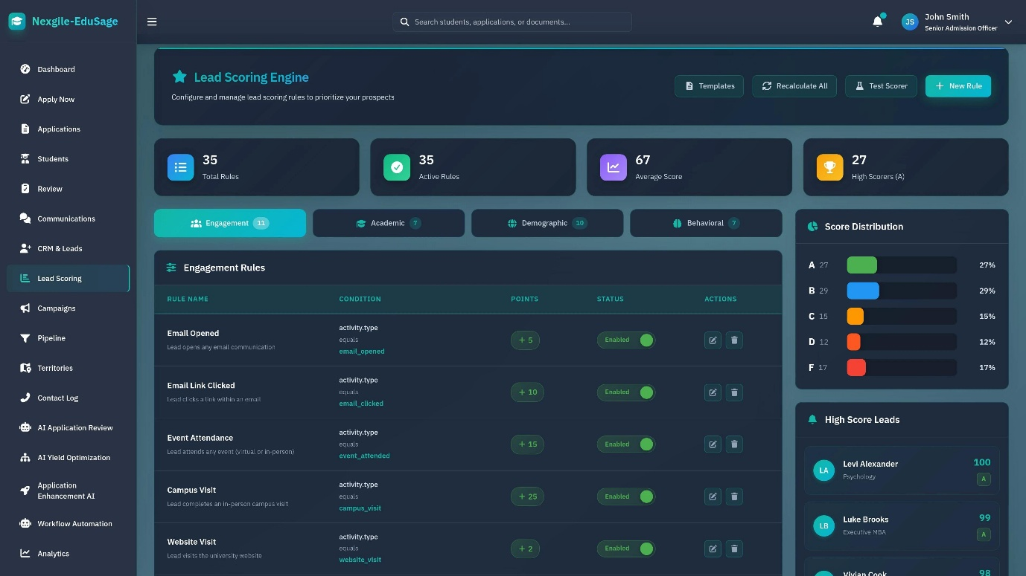
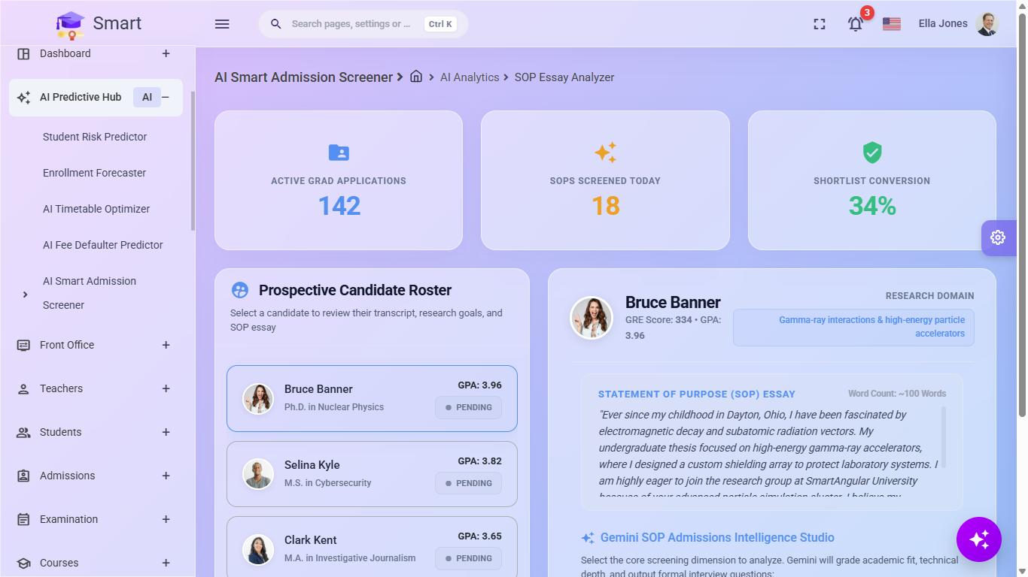
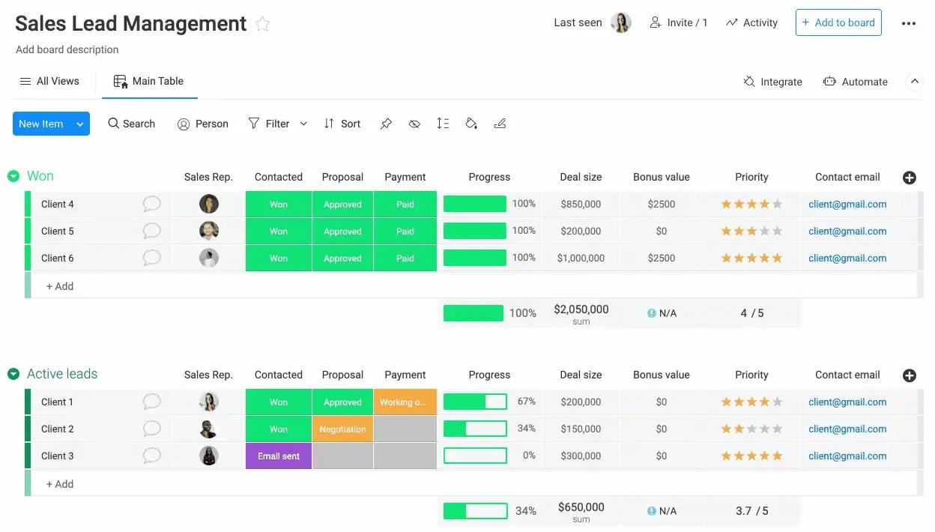
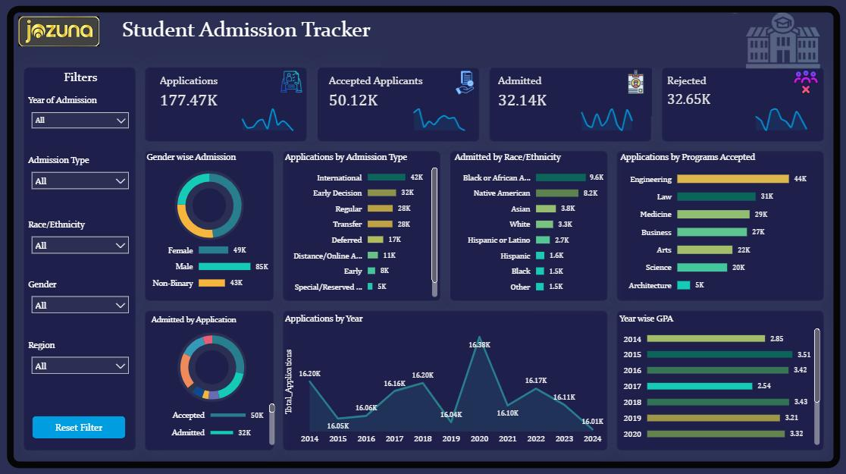
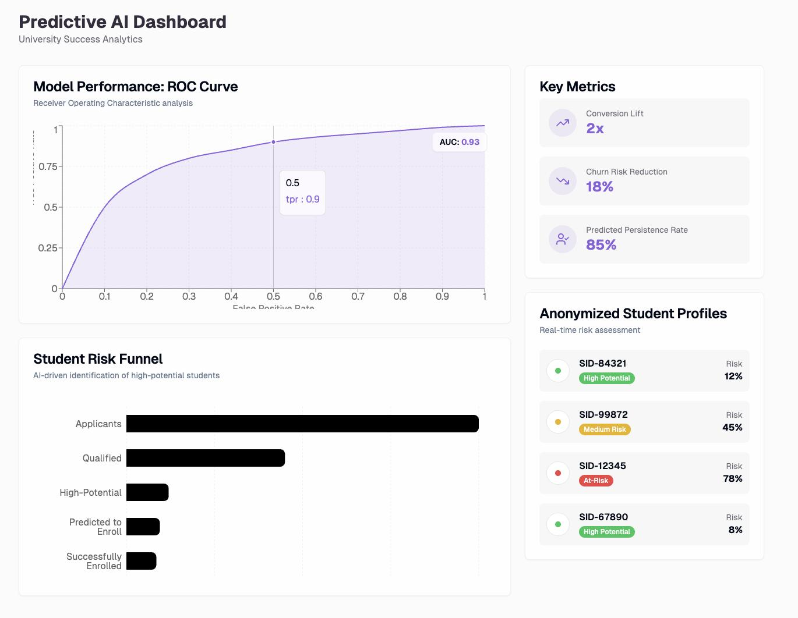
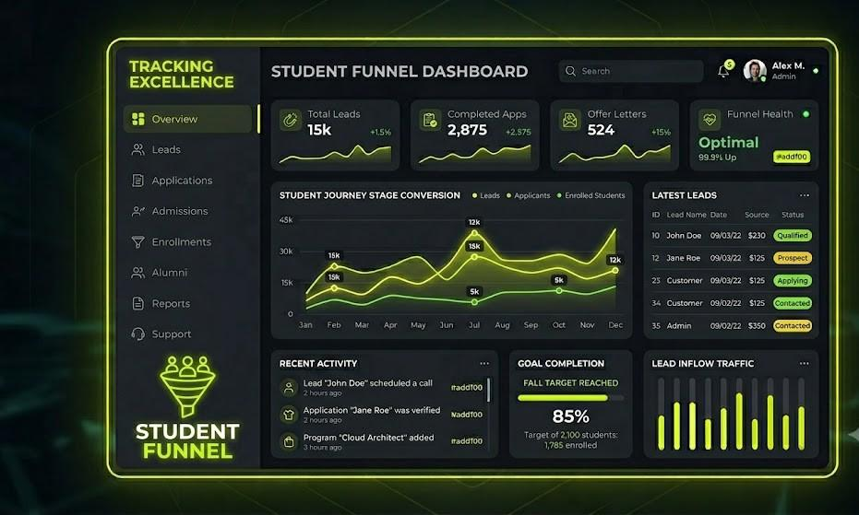
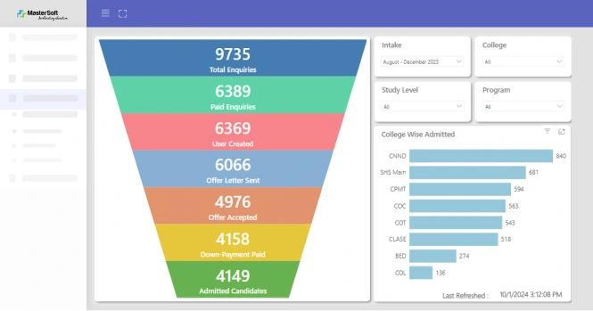
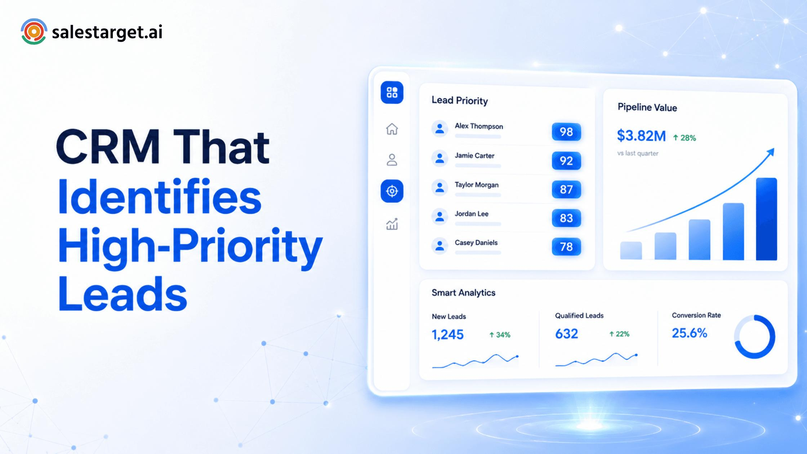
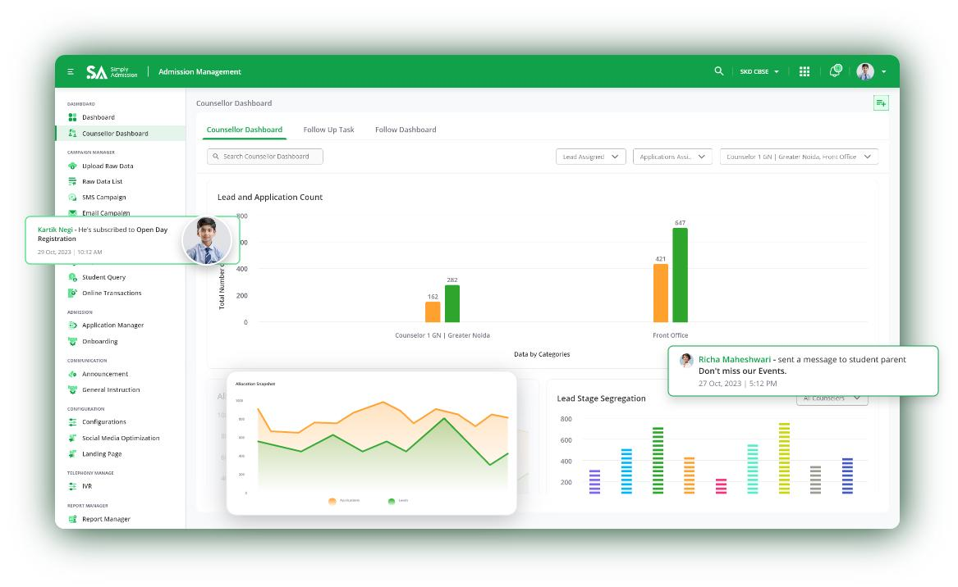
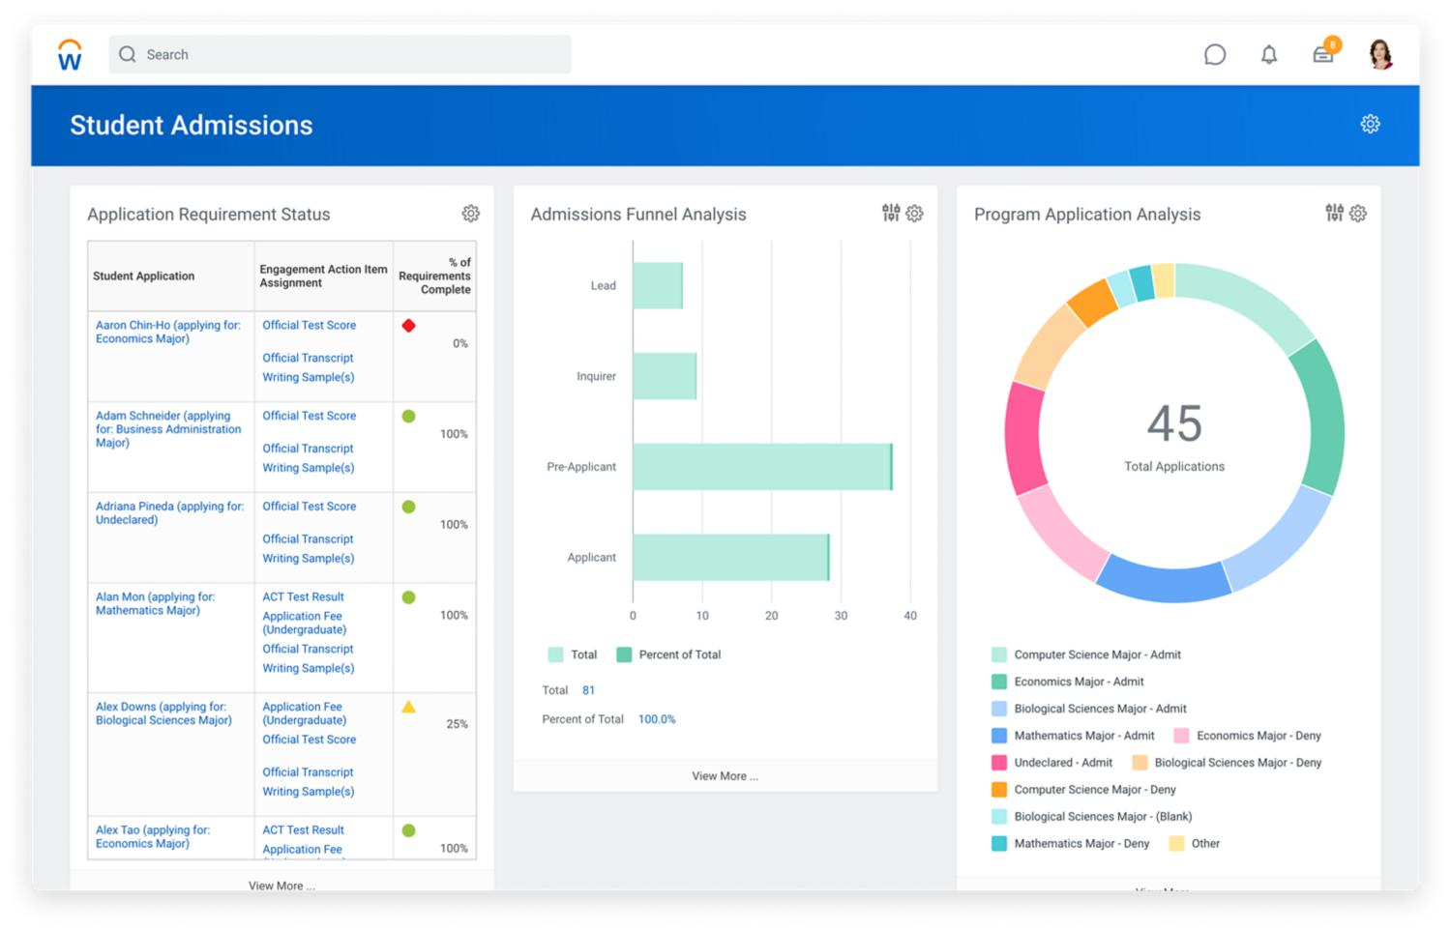
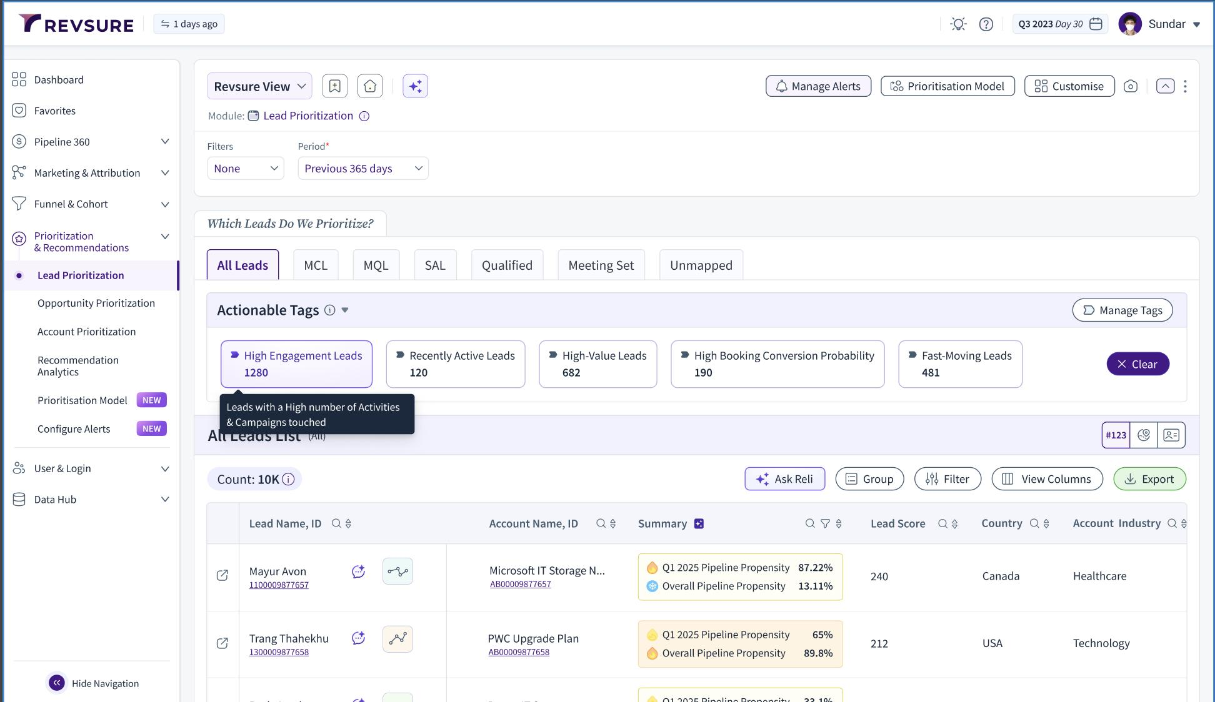
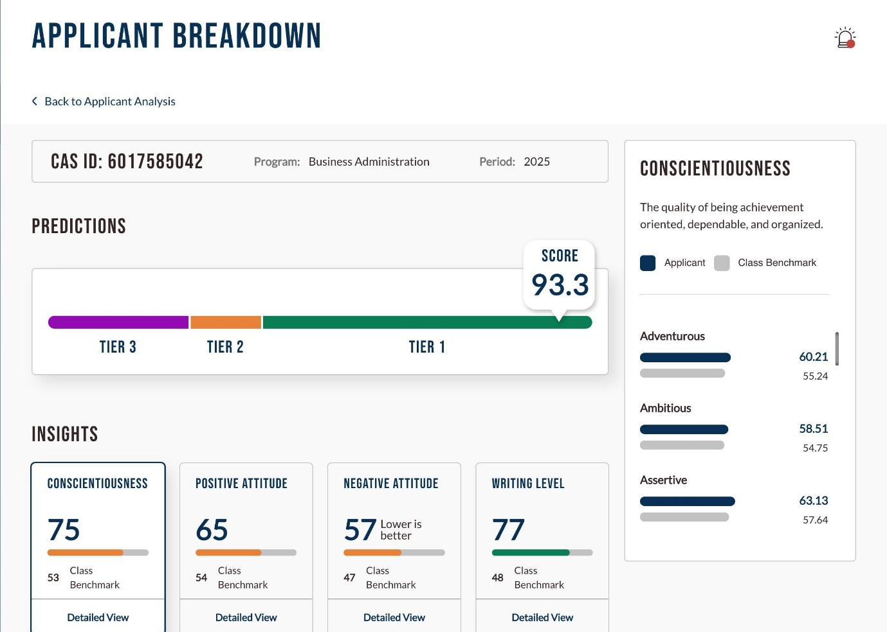
Suppose the model generates these predictions:
Lead ID | Conversion Score | Priority | Suggested Action
LEAD-101 | 89/100 | High | Contact first
LEAD-102 | 64/100 | Medium | Follow up soon
LEAD-103 | 23/100 | Low | Continue nurturing
These are illustrative examples, not actual model predictions.
The application will allow counsellors to:
- View overall admission lead statistics.
- Explore lead conversion patterns.
- Predict conversion probabilities.
- Prioritize leads.
- Understand which factors influenced a prediction.
- Upload a CSV file containing multiple leads and score them in bulk.
Important: The score estimates conversion likelihood, not a student's ability or eligibility for admission.

2. Our technology stack
We'll use tools that are relatively easy to learn and suitable for a two-day prototype.
Technology | Why we need it
Python | Main programming language
Pandas | Handle and clean data
NumPy | Numerical operations
Scikit-learn | Train the ML model
XGBoost | Compare an additional ML model
Plotly | Create interactive charts
Streamlit | Build the web application
SHAP | Explain model predictions
GitHub | Store and showcase the project
Streamlit Community Cloud | Deploy the application
We'll start with Scikit-learn and add XGBoost and SHAP only after the basic application works.
Our priority is a working application, not using the maximum number of technologies.

3. The complete development roadmap
Follow these steps in order.
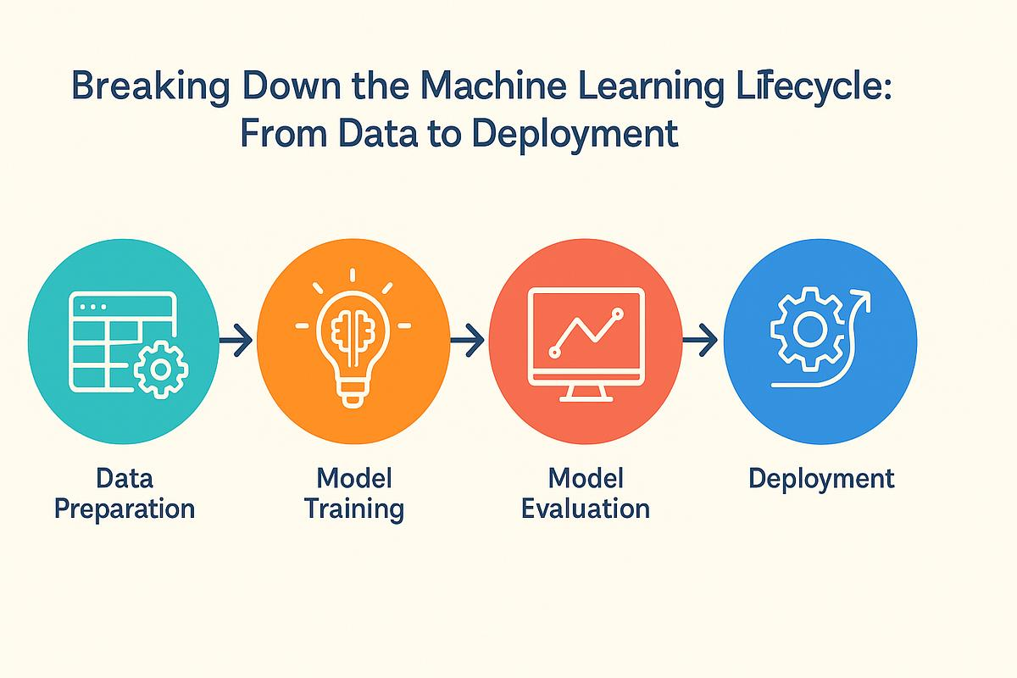
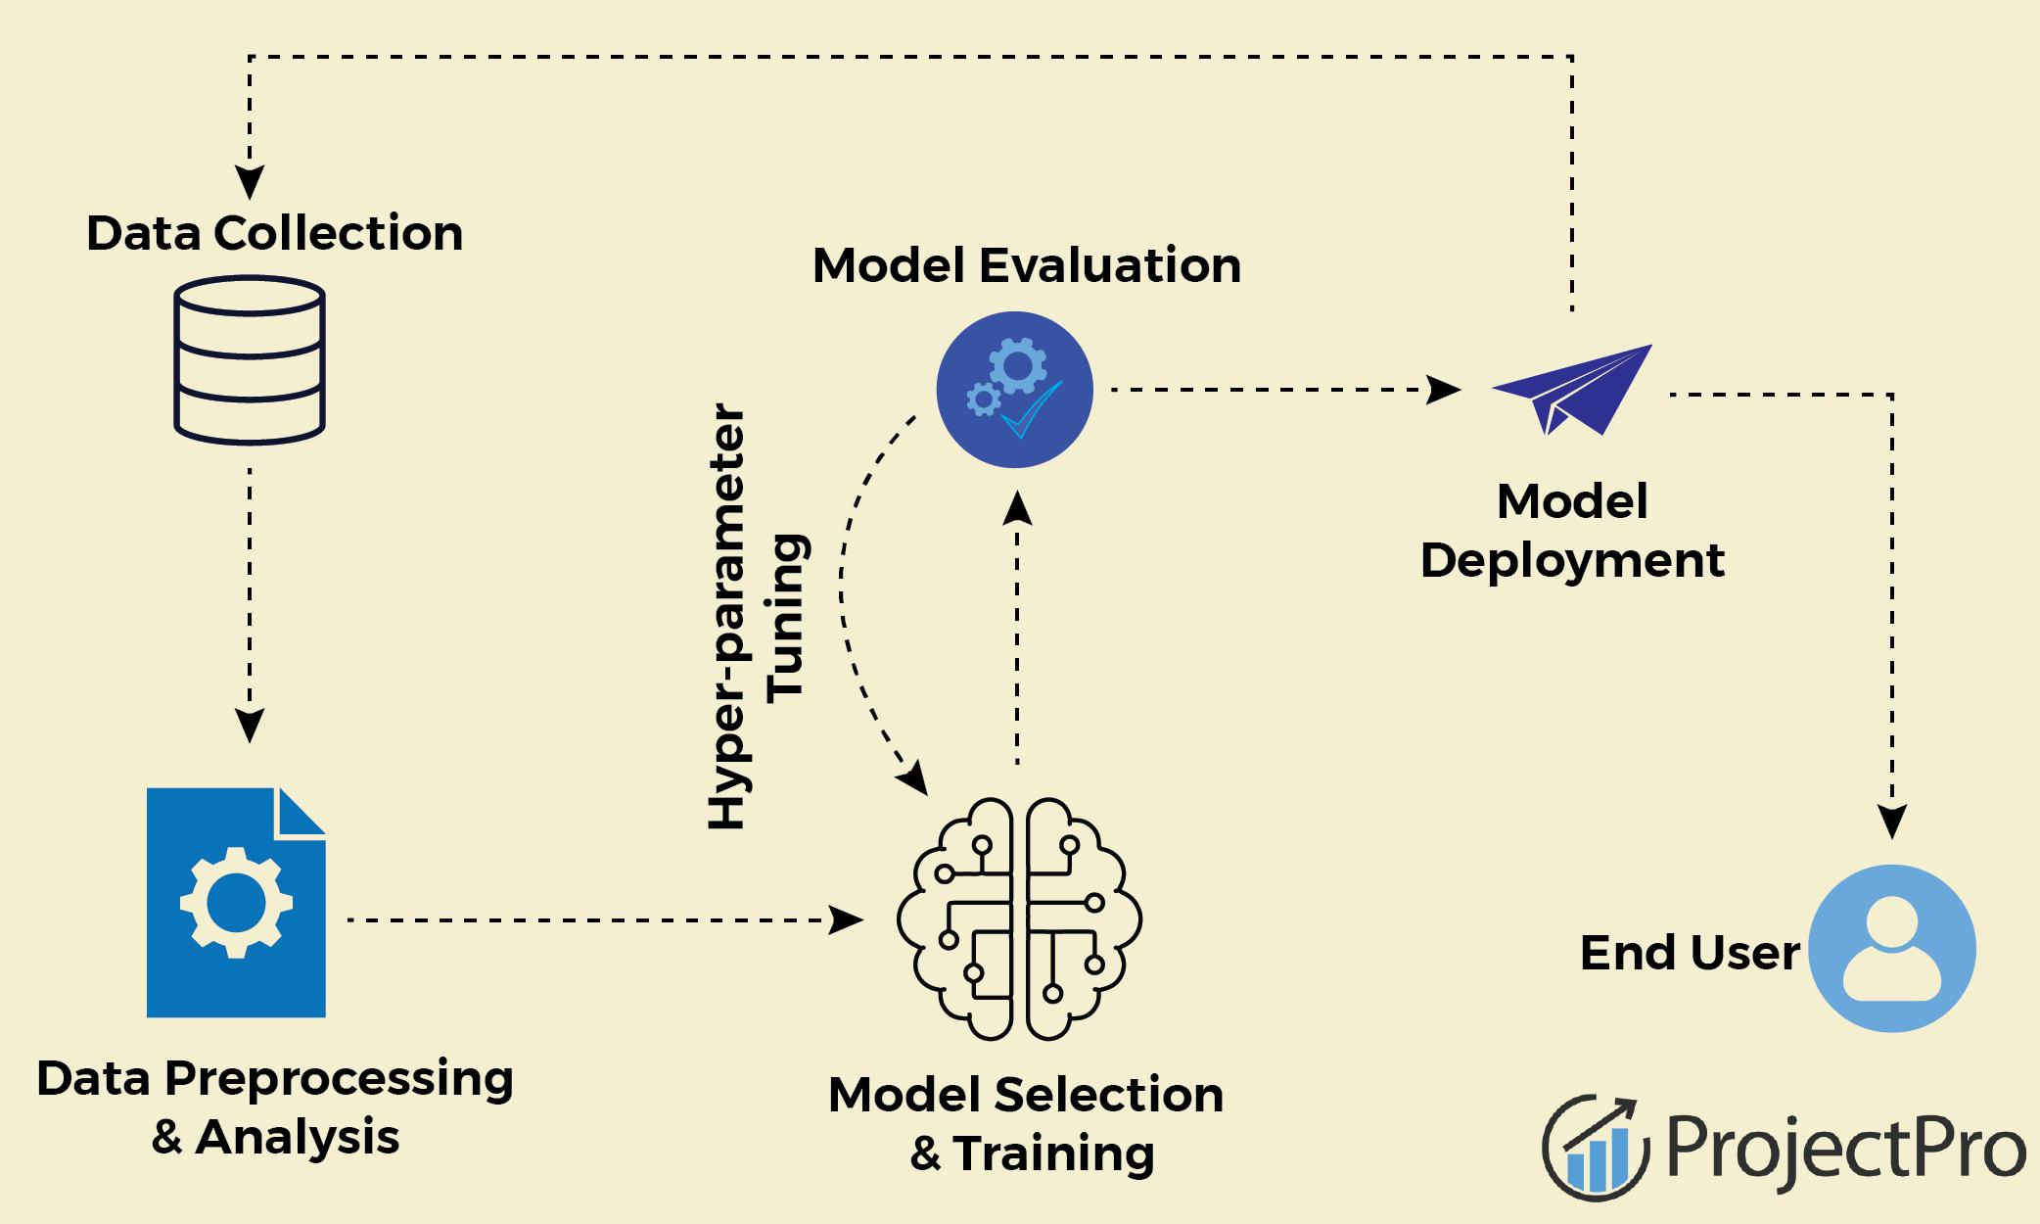
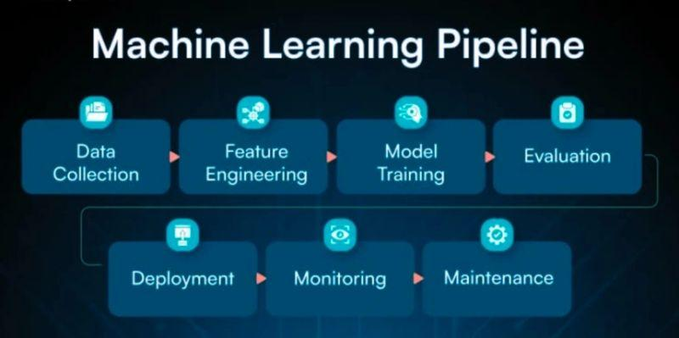
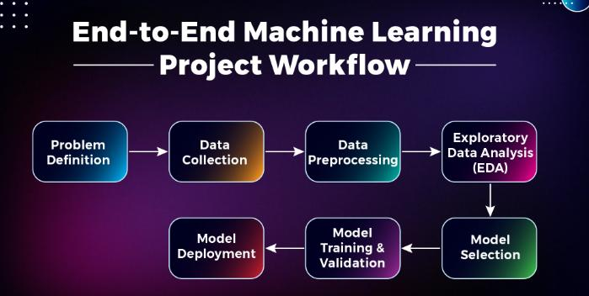
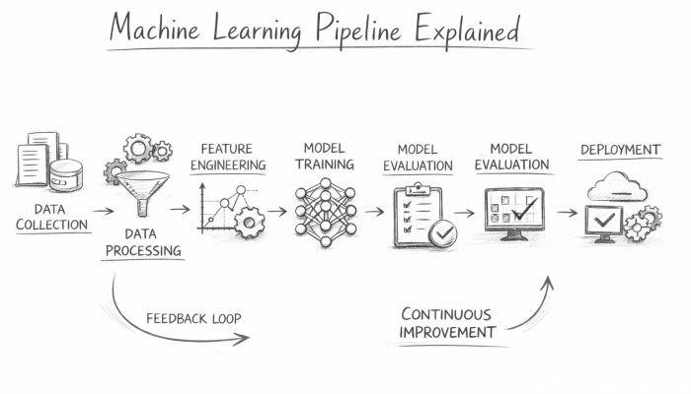
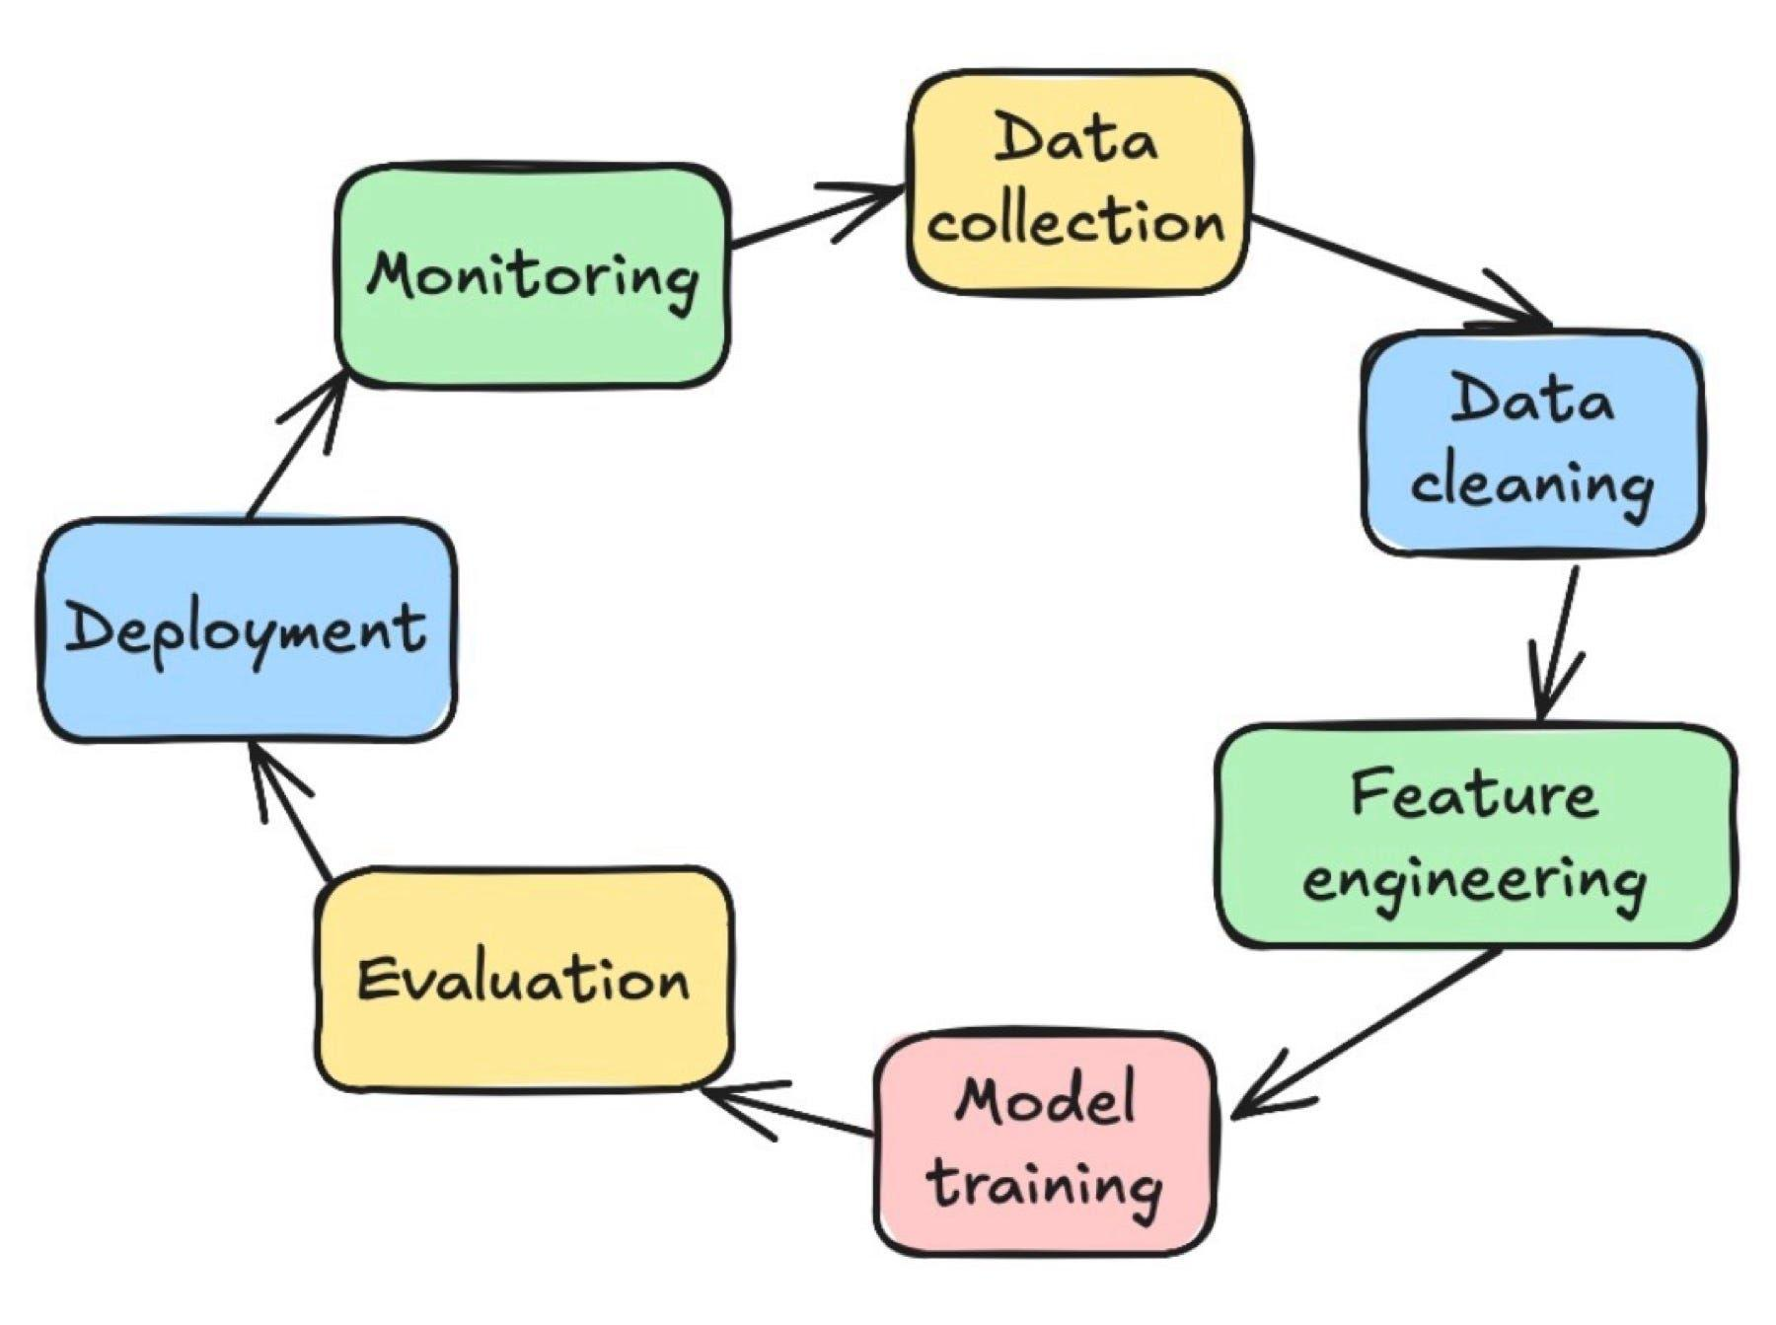
Stage | What we'll do | Expected time
1 | Set up the development environment | 30 minutes
2 | Download and understand the dataset | 45 minutes
3 | Clean and analyse the data | 1.5 hours
4 | Train and evaluate ML models | 2 hours
5 | Develop the Streamlit dashboard | 2.5 hours
6 | Add prediction explanations and polish | 1.5 hours
7 | Test, upload to GitHub and deploy | 1.5 hours
8 | Prepare presentation and viva | 1 hour
This is an approximate schedule. We may need to simplify some features if installation or deployment takes longer.
DAY 1 — Build the Machine Learning system
STEP 1. Set up your laptop
We'll use VS Code on Windows.
Install these if you don't already have them:
- Python.
- Visual Studio Code.
- The Python extension for VS Code.
- Git, if you want to manage your project using Git commands.
Create a folder named:
lead-intent-priority-scorer
Open that folder in VS Code.
Open the VS Code terminal using:
Terminal → New Terminal
Run the following commands one by one:
python --version
Then:
python -m venv .venv
Activate the virtual environment:
.\.venv\Scripts\Activate.ps1
If PowerShell blocks activation, use the VS Code Command Prompt terminal and run:
.venv\Scripts\activate.bat
Install the required packages:
python -m pip install --upgrade pip
pip install pandas numpy scikit-learn streamlit plotly matplotlib seaborn joblib
We'll install additional packages later if needed.
Checkpoint: Python works, your virtual environment is active, and the packages are installed.

STEP 2. Download the dataset
We need historical lead information to train the model.
Your project plan identifies the following dataset:
X Education Lead Scoring Dataset
Download the dataset from Kaggle
The project plan describes approximately 9,240 records and 37 columns. The target variable is Converted, where:
- 1 = The lead converted.
- 0 = The lead did not convert.
These details come from your project plan.
What does the dataset contain?
It includes information about prospective students, such as their lead source, website engagement, recorded activities, and other attributes.
The exact columns must be verified after downloading the file.
Where should you save it?
Create this structure:
lead-intent-priority-scorer/
│
├── data/
│ └── raw/
│ └── leads.csv
Place your downloaded CSV file inside data/raw/.
If the downloaded file has a different name, either rename it to leads.csv or update the filename in your code.
Checkpoint: Your CSV file is available locally.

STEP 3. Understand and clean the data
Before training a model, we need to understand the dataset.
Create a file named:
01_data_analysis.py
Start with:
import pandas as pd

df = pd.read_csv("data/raw/leads.csv")

print("Dataset shape:", df.shape)

print("\nFirst five records:")
print(df.head())

print("\nColumn names:")
print(df.columns.tolist())

print("\nMissing values:")
print(df.isnull().sum())

print("\nTarget distribution:")
print(df["Converted"].value_counts(dropna=False))
Run:
python 01_data_analysis.py
What will you learn?
A. Dataset shape
For example:
Rows: 9240
Columns: 37
Your actual output may differ.
B. Missing values
Some fields may contain missing information.
We'll decide how to handle them based on their meaning and missingness.
C. Target distribution
We need to know how many leads converted and how many did not.
This matters because a model can appear accurate while performing poorly on the less frequent class.
Next, explore conversion patterns
For example, examine whether conversion rates differ by lead source.
conversion_by_source = (
df.groupby("Lead Source")["Converted"]
.mean()
.sort_values(ascending=False)
)

print(conversion_by_source)
This assumes your dataset contains a column named Lead Source. Check the actual column names first.
We'll eventually use charts to show these patterns in the dashboard.
Checkpoint: You understand the dataset, its target variable, and the important columns.

STEP 4. Build the Machine Learning model
This is the most important part of the project.
Create:
train.py
Our training pipeline will perform these tasks:
- Load the dataset.
- Remove records with missing target values.
- Separate input features from the target variable.
- Exclude identifiers and any features that introduce data leakage.
- Split the data into training and testing sets.
- Handle numerical and categorical features.
- Train classification models.
- Compare model performance.
- Save the selected model and preprocessing pipeline.
Which models should we use?
We'll begin with two models.
Model | Why use it?
Logistic Regression | Simple baseline model
Random Forest | Captures more complex relationships
If time permits, we'll add XGBoost.
How will the model learn?
Our dataset contains historical examples.
For example:
Website Engagement | Lead Source | Converted
High | Website | 1
Low | Advertisement | 0
Medium | Referral | 1
These are illustrative examples.
The model learns patterns from the historical records and applies them to previously unseen leads.
Train-test split
We'll use a stratified split, such as:
- 80% for training.
- 20% for testing.
The test set must remain separate from model training and model-selection decisions.
Evaluate the model
We'll calculate:
- Accuracy
- Precision
- Recall
- F1-score
- ROC-AUC
We won't choose a model using accuracy alone. The best model will depend on how effectively it identifies likely converters and how many false positives the counsellors can reasonably handle.
Save the model
After selecting the model, we'll save the entire preprocessing and prediction pipeline.
For example:
models/
lead_scoring_pipeline.joblib
This allows the Streamlit application to load the trained model without retraining it every time.
Checkpoint: Your model can generate predictions for previously unseen leads, and you have a model evaluation report.

DAY 2 — Build the actual application
Now we'll turn the trained model into something you can demonstrate.
STEP 5. Create the Streamlit dashboard
Create:
app.py
We'll use Streamlit because it lets us build a web interface using Python.
The application will have five main sections.
Page 1: Executive Dashboard
Display key metrics:
- Total leads in the dataset.
- Number of converted leads.
- Overall conversion rate.
- High-priority lead count.
Include charts showing conversion patterns by source and other relevant attributes.
Page 2: Lead Analytics
Allow users to explore:
- Conversion rates by lead source.
- Conversion patterns by website engagement.
- Distribution of leads across relevant categories.
- Differences between converted and non-converted leads.
We'll build these charts using Plotly.
Page 3: Lead Scoring
This is the main feature.
The counsellor enters the available information for a prospective student.
For example:
Lead Source: Website
Website Visits: 4
Time on Website: 350 seconds
Last Activity: Email Opened
These are example inputs. We'll use the actual fields available in the dataset.
The application passes these values to the trained model.
It then displays something like:
--------------------------------
LEAD SCORING RESULT
--------------------------------

Conversion Probability: 82%

Lead Score: 82/100

Priority: HIGH

Suggested Action:
Prioritize follow-up with this lead.

--------------------------------
The probability and score shown here are illustrative.
We'll use the model's predicted probability to calculate the score:
$$\text{Lead Score}=100×P\left(\text{Conversion}=1\right)$$
For example, if the model predicts a probability of 0.82:
$$\text{Lead Score}=100×0.82=82$$
Important: A probability of 82% does not automatically mean the model is calibrated to be correct 82% of the time. We should check calibration before interpreting the number as a reliable real-world probability.
We'll also define the High, Medium, and Low thresholds explicitly and explain that they are prototype thresholds, not established admissions standards.
Page 4: Bulk Lead Scoring
This feature can make your project more practical.
The counsellor uploads a CSV file containing multiple leads.
The system returns a table such as:
Lead ID | Score | Priority
101 | 82 | High
102 | 67 | Medium
103 | 28 | Low
The counsellor can sort the results by score and download the predictions.
We'll ensure that uploaded files contain the required model input columns before making predictions.
Page 5: Model Performance
Display:
- Model comparison.
- Confusion matrix.
- Precision and recall.
- F1-score.
- ROC curve and ROC-AUC.
This page is important during your college presentation because it demonstrates that you evaluated the model rather than simply building a user interface.

STEP 6. Add Explainable AI
Your PPT includes an AI-based scoring approach. We can make the project stronger by explaining the predictions.
We'll use SHAP if time permits.
For example, the application might display:
Why did this lead receive a high score?
- Certain engagement features increased the predicted conversion likelihood.
- Some recorded interactions had a negative influence.
- Other attributes had relatively little influence on this prediction.
These explanations will come from the trained model.
We must not invent explanations or claim that a particular factor causes a student to take admission.
If SHAP installation or integration becomes difficult, don't waste hours on it. Complete the prediction workflow and dashboard first, then add explainability.

STEP 7. Organize the final project professionally
Your final folder can look like this:
lead-intent-priority-scorer/
│
├── data/
│ └── raw/
│ └── leads.csv
│
├── models/
│ └── lead_scoring_pipeline.joblib
│
├── notebooks/
│ └── exploratory_analysis.ipynb
│
├── src/
│ └── preprocessing.py
│
├── app.py
├── train.py
├── requirements.txt
├── README.md
└── .gitignore
We can expand this structure if the project grows.
Create requirements.txt with the packages actually required by your application.
For example:
pandas
numpy
scikit-learn
streamlit
plotly
joblib
Add XGBoost and SHAP only if they're used.
One important GitHub rule
Do not upload sensitive data, API keys, or large private datasets.
The dataset may be subject to the source's usage conditions. Check those conditions before redistributing it.
You can document how to obtain the dataset instead of committing the full CSV.

STEP 8. Run the application locally
From the project root, activate your virtual environment and run:
streamlit run app.py
Streamlit will provide a local address, typically:
http://localhost:8501
Open it in your browser.
Test these scenarios:
- Does the dashboard load?
- Do the charts display?
- Can the user submit a lead?
- Does the model return a score?
- Does bulk CSV scoring work?
- Does the application handle missing or invalid input?
- Does the model produce consistent results when the same input is submitted again?
Fix the errors before deploying.

STEP 9. Upload the project to GitHub
Create a new repository named:
lead-intent-priority-scorer
Use a clear description:
An ML-powered student admission lead scoring system that predicts conversion likelihood, prioritizes prospective students, and provides an interactive Streamlit analytics dashboard.
From your project terminal, run:
git init
git add .
git commit -m "Build lead intent and priority scoring system"
git branch -M main
git remote add origin YOUR_GITHUB_REPOSITORY_URL
git push -u origin main
Replace YOUR_GITHUB_REPOSITORY_URL with the actual URL of your newly created repository.
Make sure your .gitignore excludes your virtual environment and other unnecessary local files.

STEP 10. Deploy the dashboard
Use Streamlit Community Cloud.
The general workflow is:
- Sign in.
- Connect your GitHub account.
- Select your project repository.
- Select the main branch.
- Set app.py as the application entry point.
- Deploy the application.
- Open the public URL and test it.
Deployment can take longer than expected, so leave time for troubleshooting.
Also, make sure the deployed application does not depend on a dataset or model file that exists only on your laptop.

4. Your exact two-day schedule
Here's how I'd prioritize the work.
Task | Day 1 | Day 2
Environment setup | ✓
Dataset download and inspection | ✓
Data cleaning and EDA | ✓
Train-test split and ML pipeline | ✓
Model evaluation | ✓
Lead scoring interface |  | ✓
Executive dashboard |  | ✓
Bulk scoring |  | ✓
SHAP explanations |  | ✓ If time permits
Testing and bug fixes |  | ✓
GitHub and deployment |  | ✓
Presentation and viva preparation |  | ✓
If you fall behind
Prioritize these five deliverables:
- A working dataset and preprocessing pipeline.
- A trained model with evaluation results.
- A working lead scoring interface.
- A dashboard showing analytics and model performance.
- A GitHub repository with documentation.
A working, well-tested application is better than a dashboard with many features that don't function.

5. How to explain your project during the presentation
You should be able to explain these six points clearly.
1. What problem does your project solve?
It helps admission counsellors prioritize prospective students using predicted conversion likelihood instead of relying entirely on manual judgement.
2. What dataset did you use?
The X Education Lead Scoring dataset, which contains historical lead attributes and a binary conversion target.
3. Why did you use Machine Learning?
To identify patterns in historical lead data and estimate the conversion likelihood of previously unseen leads.
4. Which algorithms did you use?
Logistic Regression and Random Forest, with XGBoost as an optional additional model.
5. How did you evaluate the model?
Using a held-out test set and metrics such as precision, recall, F1-score, and ROC-AUC, alongside accuracy.
6. What is the final output?
An interactive dashboard that displays lead scores, priority categories, analytics, and model performance.
Be honest about your results. Don't claim that the model increases actual admissions or conversion rates unless you have conducted a suitable real-world evaluation.

6. What you should do RIGHT NOW
Don't try to complete every feature simultaneously.
Let's start with the foundation.
Your first 30 minutes
- Install or open VS Code.
- Check whether Python is installed.
- Create the lead-intent-priority-scorer folder.
- Open the folder in VS Code.
- Open the terminal.
- Create and activate your virtual environment.
- Install the required packages.
Then we'll do the next step together
Once your environment is ready, we'll download the dataset, inspect its actual columns, and create the first working Python script.
One final recommendation: Since you have only two days, we should build the minimum working application first and add advanced features only after the core workflow works.
Tell me just one thing: Is Python and VS Code already installed on your laptop, or do you need to install them?
I'll guide you from that exact point, including the commands and complete code for each step.

